Series and Parallel Pumps Experiment

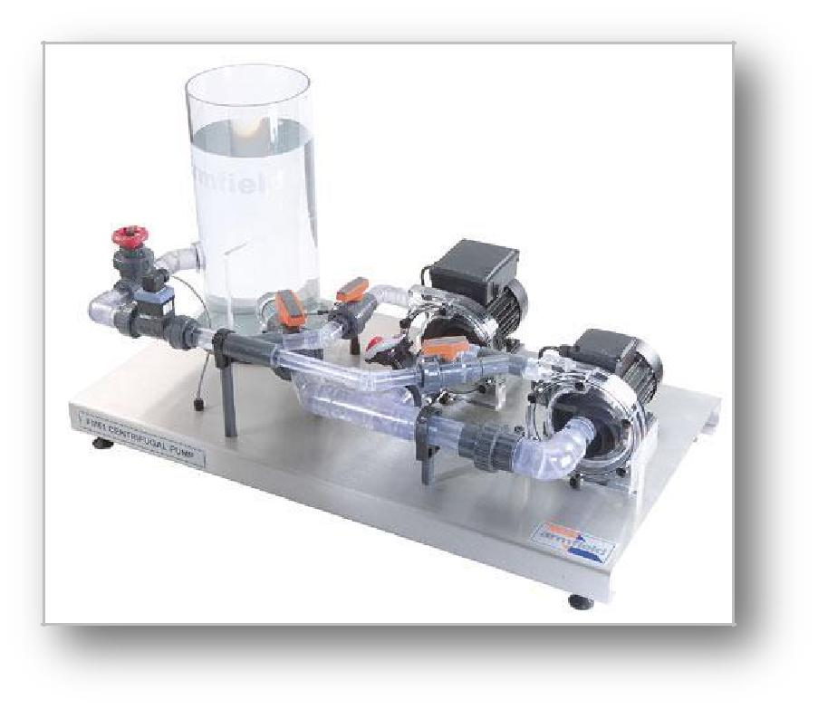

**Series and parallel pump demonstration unit**

# Introduction:

Centrifugal pumps are often used together to enhance either the flow rate or the delivery pressure beyond that available from the single pump. For some piping system designs, it may be desirable to consider a multiple pump system to meet the design requirements. Two typical options include parallel and series configurations of pumps which require specific performance criteria. In serial operation the heads of the pumps are added and in parallel operation the flow rates (capacities) of the pumps are added.

The experimental unit provides the determination of the characteristic behavior for single operation and interaction of two pumps. The apparatus consists of a tank and pipe work which delivers water to and from two identical centrifugal pumps. The unit is fitted with electronic sensors which measure the process variables. Signals from these sensors are sent to a computer via an interface device, and the unit is supplied with data logging software as standard.

Purpose:

To investigate the result on discharge and total head of operating pumps in series and parallel.

Series pumps

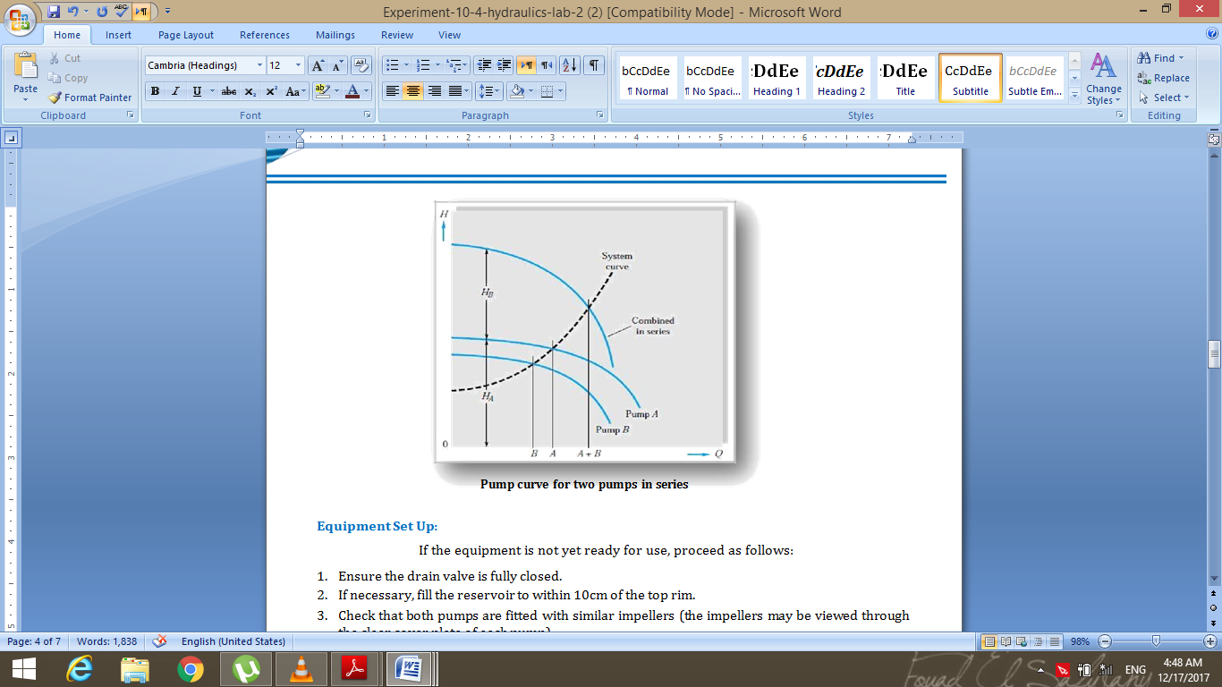A single pump may be insufficient to produce the performance required. Combining two pumps increases the pumping capacity of the system. Two pumps may be connected in series, so that water passes first through one pump and then through the second. When two pumps operate in series, the flow rate is the same as for a single pump but the total head is increased. The combined pump head-capacity curve is found by adding the heads of the single pump curves at the same capacity.

Parallel pumps

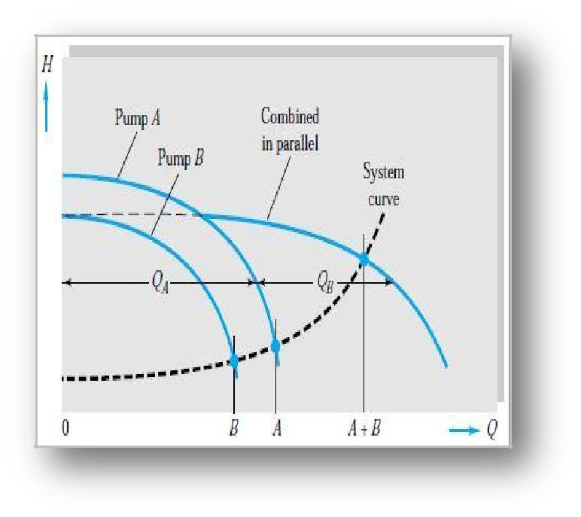

A single pump may be insufficient to produce the performance required. Combining two pumps increases the pumping capacity of the system. Two pumps may be connected in parallel, so that half the flow passes through one of the pumps and the other half through the second pump. When two pumps operate in parallel, the total head increase remains unchanged but the flow rate is increased. The head-capacity curve is found by adding the capacities of the single pump curves at the same head.

**Pump curve for two pumps in parallel**

# Procedure:

1-Adjust the isolation valves in the experiment module so that a single pump of the two pumps operates and circulates the flow while the other pump lines are off.

2-Take the orifice reading for flow rate and take the manometer reading for the working pump.

3-Change the flow control valve adjustment to change the water flow rate.

4-Again take the orifice reading for flow rate and take the manometer reading for the working pump and repeat the previous two steps until you have for readings as minimum when the valve is totally closed.

5-Change the adjustment of the isolation valves to make the two pumps work in series.

6-Take the flow rate orifice reading and the reading of the two manometers installed on the pumps.

7-Change the flow control valve adjustment to change the water flow rate and take the orifice reading with the reading of the two manometers installed on the pumps for four times as minimum.

8- Change the adjustment of the gate valves to make the two pumps work in parallel.

9-Take the orifice reading to calculate mass flow rate and the reading of the two manometers installed on the pumps to calculate the head made by each pump and finally repeat this step after adjusting the flow control valve for four times as minimum.

Readings obtained from a previously done experiment:

|  |  |  |  |  |  |  |  |
| --- | --- | --- | --- | --- | --- | --- | --- |
| **Single pump** | | | | | | | |
| **Y(cm)orifice** | | **Q ($m^{3}/s$)** | | $$h$$ | | $$H_{m}(m)$$ | |
| 8 | | $$35.473*{10}^{-5}$$ | | 42 | | 5.292 | |
| 4 | | $$25.083*{10}^{-5}$$ | | 58 | | 7.308 | |
| 3 | | $$21.723*{10}^{-5}$$ | | 62 | | 7.812 | |
| 0 | | 0 | | 81 | | 10.206 | |
| **Parallel pumps** | | | | | | | |
| **Y(cm)orifice** | | **Q($m^{3}/s$)** | | $$h$$ | | $$H_{m}(m)$$ | |
| 20 | | $$65.169*{10}^{-5}$$ | | 42 | | 5.292 | |
| 15 | | $$56.088*{10}^{-5}$$ | | 58 | | 7.308 | |
| 12 | | $$43.446*{10}^{-5}$$ | | 62 | | 7.812 | |
| 0 | | 0 | | 81 | | 10.206 | |
| **Series pumps** | | | | | | | | |
| **Y(cm)orifice** | **Q($m^{3}/s$)** | | $$h$$ | | $$h$$ | | $$H_{mtot}(m)$$ | |
| 8 | $$35.473*{10}^{-5}$$ | | 37 | | 35 | | 9.072 | |
| 6.5 | $$31.9753*{10}^{-5}$$ | | 47 | | 41 | | 11.008 | |
| 4 | $$25.084*{10}^{-5}$$ | | 58 | | 59 | | 14.742 | |
| 0 | 0 | | 81 | | 82 | | 20.538 | |

Comparison with real graph:

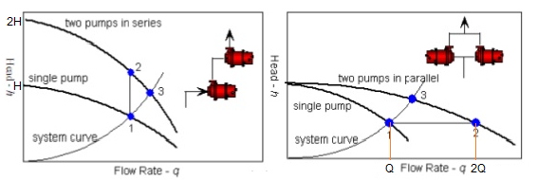

It is clear that working two identical pumps in series will have a (H-Q) curve doubled in head with constant flow rate while working two identical pumps in parallel will have a (H-Q) curve doubled in flow rate with constant head.